**Worksheet**

**EXPERIMENT – 4**

**Name: Sahul Kumar Parida**

**Class: 34A Group: 3 Subject: AI Applications Lab**

**UID: 20BCS4919**

**Aim:**

Perform Speech-to-text conversion using pre trained machine learning API models for short-form or long-form audio.

**Requirements:**

PC with internet connectivity, Python 3.7

**Expected Outcome:**

**Code:**

**# Python program to translate**

**# speech to text**

**import speech_recognition as sr**

**import pyttsx3**

**# Initialize the speech recognizer with microphone**

**r = sr.Recognizer()**

**# Function to convert speech to text**

**def SpeakText(command):**

**# Initialize the engine**

**engine = pyttsx3.init('dummy')**

**engine.say(command)**

**engine.runAndWait()**

**# Loop infinitely for user to speak**

**text_length=0**

**# It will going to continue run until it count the text length less than 10.**

**while(text_length<10):**

**# Exception handling to handle**

**# exceptions at the runtime**

**try:**

**# use the microphone as source for input.**

**with sr.Microphone() as source2:**

**# wait for a second to let the recognizer**

**# adjust the energy threshold based on**

**# the surrounding noise level**

**r.adjust_for_ambient_noise(source2, duration=0.2)**

**#listens for the user's input**

**audio2 = r.listen(source2)**

**# Using google to recognize audio**

**MyText = r.recognize_google(audio2)**

**MyText = MyText.lower()**

**print("Message: \n"+MyText)**

**SpeakText(MyText)**

**text_length=len(MyText)**

**print(text_length)**

**except sr.RequestError as e:**

**print("Could not request results; {0}".format(e))**

**except sr.UnknownValueError:**

**print("unknown error occured")**

**Output:**

**For word length greater than 10**

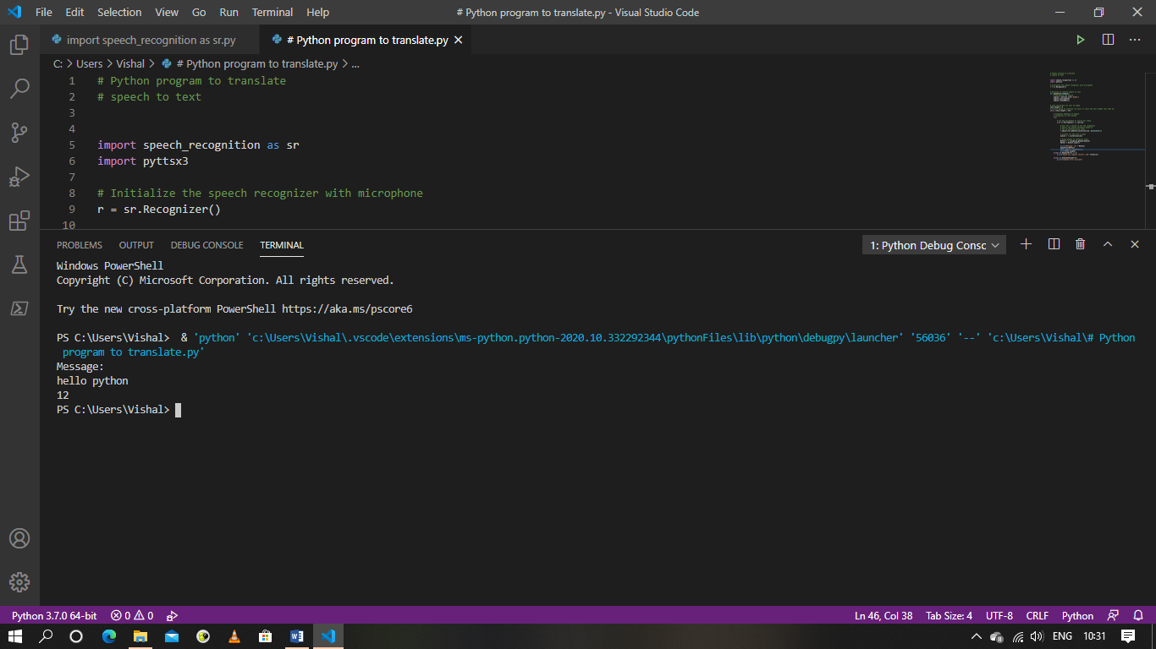

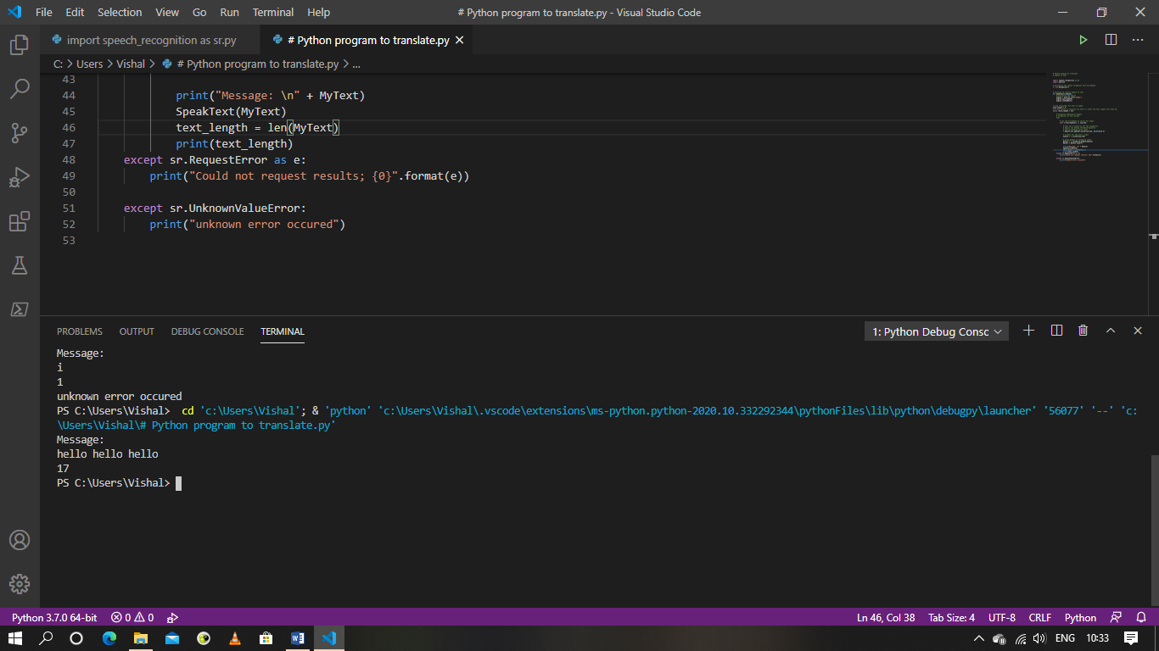

**For word length less than 10**

